# 23056_Green Warriors_CAD Report

## Author’s Name: Abdus Samad Co-Author’s Name: Mohd Munazir Mairaj

**Introduction**

Revolutionize your design process with our cutting

edge approach! Seamlessly integrating CAE immediately after crafting our fundamental CAD model

,we leverage the power of Ansys workbench 19.2. This not only refines designs but also prioritize drivers safety, ensuring an unparalleled synergy between innovation and security

## FRAME MATERIAL DETAILS

Material-1 (AISI1018) Rectangular; 1.5in x 1.00in x

0.0787in(2.00mm)

Material-2 (AISI1018) Square; 1.00in x 1.00in x 0.0787in(2.00mm)

Material-3 (AISI1018) Circular; 1.00in x 0.842in x

0.0787in(2.0 Material Selection Parameter: Material Selection Parameter: 0mm)

Material-4 (AISI41 Material Selection Parameter: Material Selection Parameter: 30) Circular; 1.00in x 0.842in x 0.0787in(2.00mm

## CALCULATION OF BENDING STRENGTH AND BENDING STIFFNESS

Formula used:

* 1. Bending strengths = (Sy x I)/c
  2. Bending Stiffness = E x I

Where, Sy = yield strength I = second moment of inertia of the cross section

c = Distance of the extreme fiber of the cross section from the neutral axis

E = Modulus of Elasticity Reference Material in Rulebook:

AISI 1018 – Circular 1in x 0.842in x 0.0787in (2.00mm) I = [3.14 x {(25.4)4 – (21.4)4 } x 10-12]/64 = 1.0132 x

|  |  |  |  |  |  |  |
| --- | --- | --- | --- | --- | --- | --- |
| Strength | | | | 5 points | | |
| Cost | | | | 4 points | | |
| Bweight | | | | 3 points | | |
| Availability | | | | 3 points | | |
|  | | *Strengt*  *h* | *Cost* | | *Weig*  *ht* | *Availability* |
| *AISI 1018* | | *7* | *6* | | *6* | *9* |
| *AISI 1020* | | *5* | *6* | | *6* | *6* |
| *AISI 4130* | | *9* | *4* | | *7* | *7* |
| *Material* |  | | | *Score* | | |
| *AISI 1018* | **5*7+4*6+3*6+3**  **\*9** | | | 104 | | |
| *AISI 4130* | **5*9+4*4+3*7+3**  **\*7** | | | *103* | | |

10-8 m4

c = 0.0127 m

Bending strength = {365 X 1.0132 X 10-2 }/0.0127 =

291.19 N-m

Bending Stiffness = 205 x 1.0132 x 10 = 2077.06 N-m2

|  |  |  |  |
| --- | --- | --- | --- |
|  |  | **Bending Strength** | **Bending Stiffness** |
| **Unit** | **inch** | **N-m** | **N-m2** |
| **Reference**  **Material** | AISI 1018 | 291.19 | 2077.06 |
| **Cross Section** | A=1 B=0.842 T=0.0787 |  |  |
| **Material-1** | AISI 1018 | 901.20 | 9558.4 |

**Analysis Results:**

|  |  |  |
| --- | --- | --- |
| 6mm | 40-45 | 7-9% |
| 5 mm | 50-55 | 3-6% |
| 4 mm | 80-90 | 1-2% |
| 3 mm | System not able to process |  |

## CAE ANALYSIS OF VEHICLE/FRAME

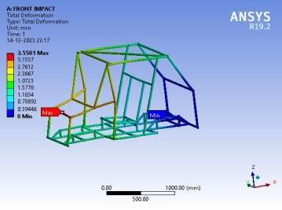

* 1. **FRONTAL IMPACT ANALYSIS**

### Assumption & Consideration

We assumed that the vehicle collides with wall

l. Mass of the vehicle with driver = 250 Kg

Modulus of elasticity = 205 GPa Poisson’s ratio = 0.29

The maximum allowed speed is = 35 km/h

=9.72m/s

Initial velocity v = 10 m/s

Final velocity after impact will be (u=0)

Therefore vehicle stops.

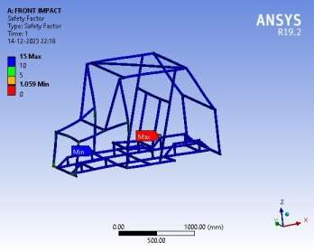Assume impact time = 0.15

sec

### Calculation of Impact Forces:

Work done = Change in kinetic energy F * v * t =1/2 m(v^2-u^2)

F = 1/2 mv^2 * 1/V *T

(u=0)

F = 1/2 * 250 * 10 /0.15 F = 8333.33

F = 8334 N.

## SIDE IMPACT ANALYSIS

### Assumption & Considerations:

We assumed that another vehicle will hit the vehicle on

side

Mass of vehicle and two drivers = 250kg Modulus of elasticity = 205 GPa

Poisson’s ratio = 0.29

Impact time = 0.3 sec

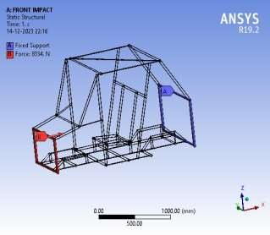Base frame was considered as the fixed support. Vehicle was considered to be in static state and the force corresponding to velocity 10 m/sec with impact time of 0.3 seconds was applied to the front of the side protection member of the vehicle (since, collision takes place between two deformable bodies, i.e. vehicles

### Calculation of Impact Forces:

Mass of the vehicle and the drivers, M = 250 kg Initial velocity before impact = 10 m/sec

Final velocity after the impact will be zero. Impact time 0.3 seconds

Work done = Change in kinetic energy

Work done = Power*time = Change in kinetic

energy

F*v*t = ½ m (v^2-u^2) F =1/2 mv^2 * 1/v*t

F = 1/2 * 250 * 10/0.3 F = 4166.66

F = 4167 N

### c ) Analysis Results:



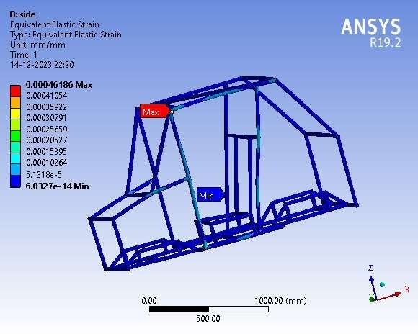

**d) Optimizations:**

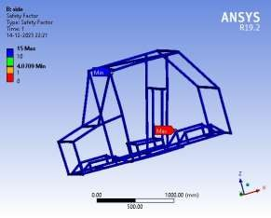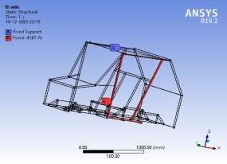

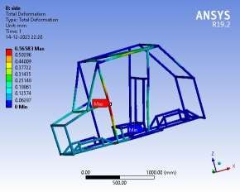We were getting huge level of stress on the A arm mounting pipes which might fall on high impacts so we optimized our design and used ribs to support the a arm mounting pipes

## ROLLOVER ANALYSIS

### Assumption & Considerations:

In Roll over impact, vehicle is considered to be dropped from a height of 1136 mm or 44.8 inches (height of our vehicle)

Mass of the vehicle and two drivers = 250 kg

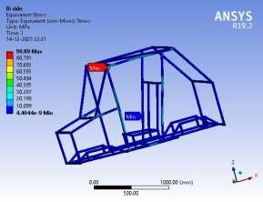Modulus of elasticity = 205 GPa Poisson’s ratio = 0.29

Base Frame was considered as the fixed support Vehicle was considered to be in static state and force corresponding to calculated velocity 4.852 m/sec with impact time of 0.15 seconds was applied to the top of roll cage of the vehicle (since collision takes place between a deformable body, i.e., vehicle and non- deformable body, i.e., wall)

### Calculation of Impact Forces:

Mass of the vehicle and the drivers, M = 250 kg

Height of fall, H = 1200 mm Impact time = 0.15 seconds

During the fall, the whole potential energy changes into

kinetic energy

M*g*h = 0.5*M*v2

V = (2*9.81*1/2) = 4.852 m/sec

Work done = Change in kinetic energy

Work done = Power*time = Force*velocity*time 0.5*M*v2 = F*v*t

F = 0.5*M*v/t

F= 0.5*250*4,852/0.15 F= 4044 N

### Analysis Results:

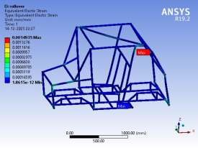

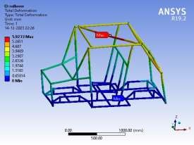



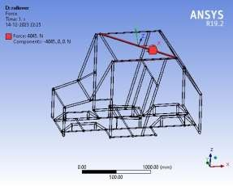

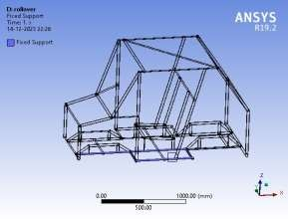

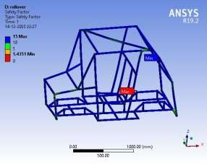

* 1. **Optimizations:**

In our initial design the DBM and LCM was joined to the OHPM through welding at a very close distance but in that design there was huge stress at the joint.

So we optimized our design and changed the direction of DBM and shifted it to 2 in. from the each end of OHPM where DBM was connected so it helped our model to reduce the stress at corner areas

## REAR IMPACT ANALYSIS

### Assumption & Considerations:

Vehicle was considered to be in static state with both sides of the frame to be fixed at the place of A arms and load was acted upon the rectangular frame through the structural members supporting both the drivers.

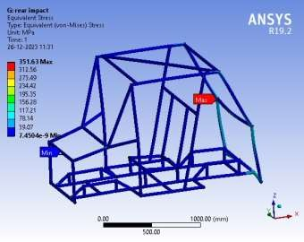Mass of the vehicle and drivers =250 Kg Modulus of elasticity = 205

GPa Poisson’s ratio = 0.29

### Calculation of Forces:

Work done = Change in kinetic energy F *v*t =1/2 m(v^2-u^2)

F=1/2 mv^2 * 1/V * T

(u=0)

1/2 * 250 * 10 /0.15)

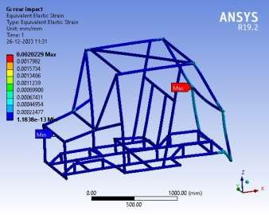F = 8333.33 F = 8334 N.

* 1. **Analysis Results:**

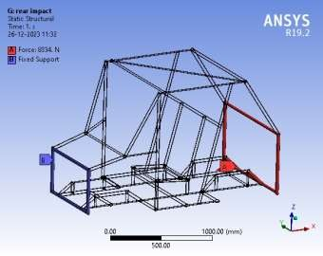

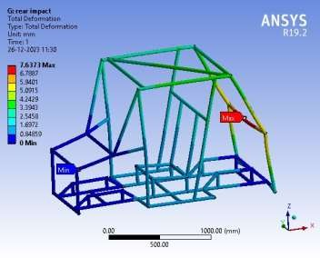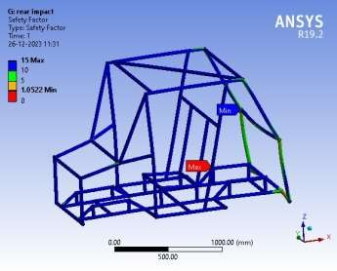

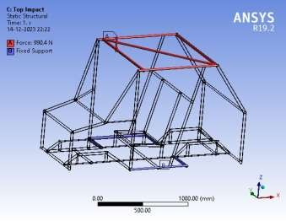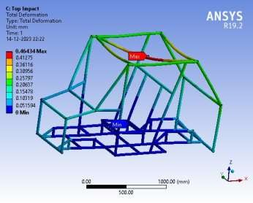

## TOP IMPACT ANALYSIS

* 1. **Assumption & Considerations**: Mass of each driver= 115 kg

Apparent mass acting at the time of braking=60 kg

### Calculation of Forces:

So deceleration, a = (6.94)2 /(2*3) a=8.027m/s2

Force exerted by driver on seat belt during sudden braking,

F= 60*8.027

= 481.62 N.

### Analysis Results:

* 1. **Suspension ansion mounting**

### Assumption & Considerations:

The vehicle has to stop within a distance of 3m with

initial speed of 25 km/h i.e. 6.94m/s (extreme braking). So deceleration, a=(6.94)2 /(2*3)

a=8.027 m/s2

### Calculation of Forces:

Static load, Fs = 85*9.81

= 833.85 N

Additional load transfer,

FL = 350*8.032*0.335/1.024 FL = 919.68N

Total load on one wheel A-arm mounting,

*.*

## 3. CAE ANALYSIS OF OTHER PARTS

### Wheel Hub

1. **Assumption& Considerations:**

We chose structural steel to fabricate wheel hub whose Modulus of Elasticity is 205 GPa and Poisson’s ratio is 0.29.Mesh size of 2 mm was taken. For worst case scenario we considered 2.5g force

### Calculation of Forces:

Mass on wheel=30% of total vehicle mass

=0.3*350 =105 kg

Force = 2.5*105*9.81

=2575N

### Analysis Results:

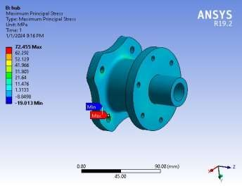

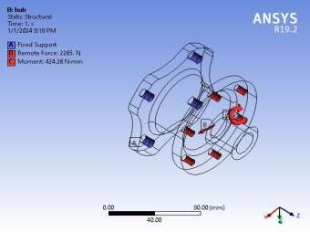

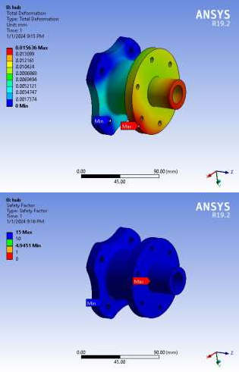**Upright**

### Assumption & Considerations:

The vehicle is cornering with a speed of 30km/h

(8.33m/s) around a circle, taking turning radius=2.8 m

### Calculation of Forces:

Fy (Lateral force)=mv2 /r (Centrifugal force) Fy = 350*(8.33)2 /3.585

Fy = 6774.37 N

Now, F2=static vertical load+ lateral load transfer Static vertical load, Fs=929.5 N

Lateral load transfer, Ft=W*a*h/d

Where, W = total weight

a = Lateral acceleration h = C.G. height

d = track width Now, F2=Fs+ Ft

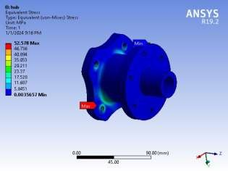=929.5+ (350*10.08*0.335)/(1.42)

=1773.9 N

### Analysis Results:

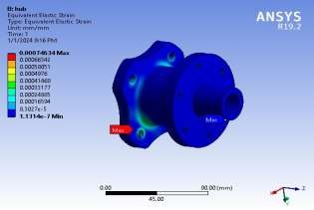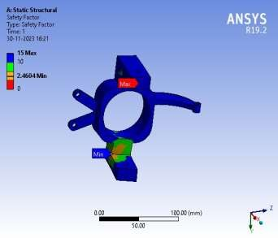

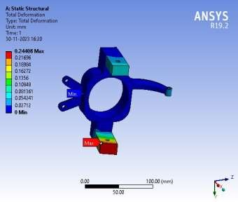 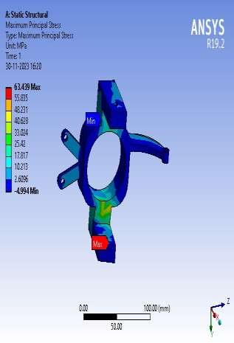

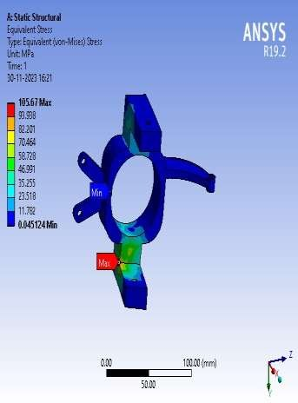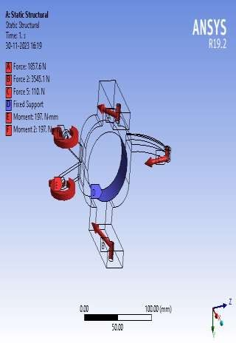

### Optimizations:

Initially cylindrical members were used to hold the A arm mounts in the upright. But in this design, we were getting high deformation of A-arm mounts, so we optimized our design and used cuboidal members to hold the A arm mounts.

# APPENDIX-1: Vehicle View

1.

## Figure-1 (Isometric View of Vehicle)

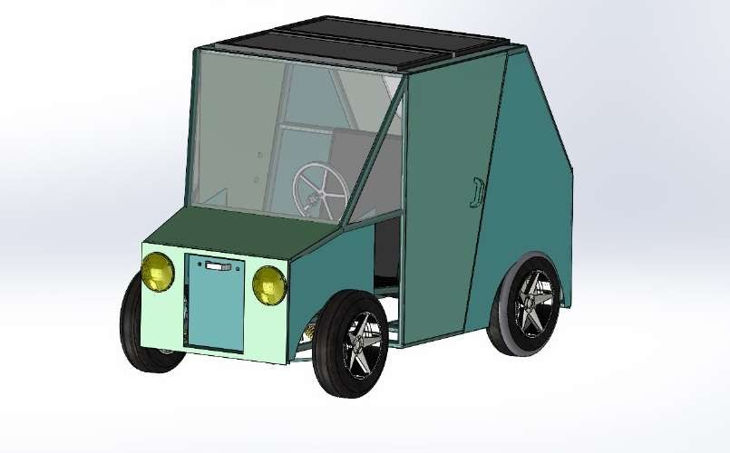

**Figure-2 (Side View of Vehicle)**

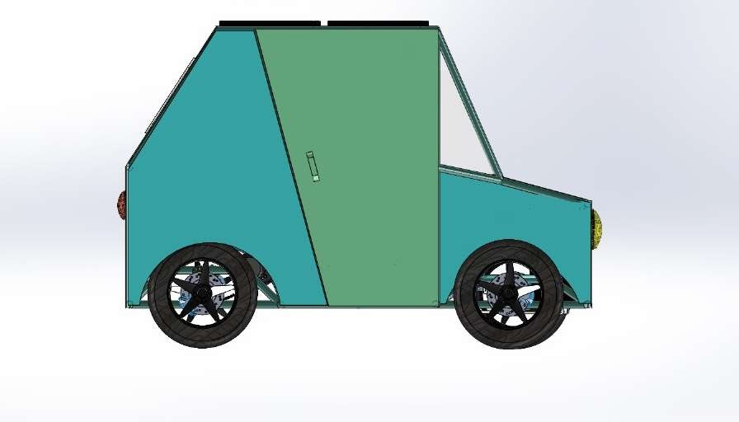

## Figure-3 (Top View of Vehicle)

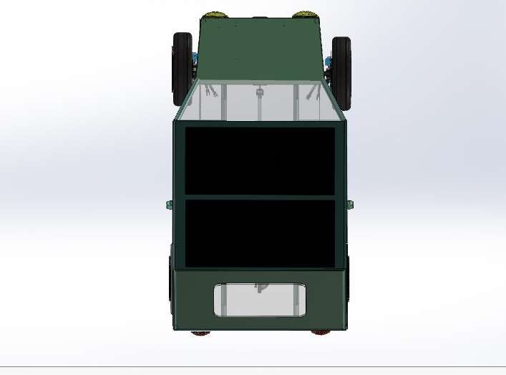

**Figure-4 (Front View of Vehicle)**

